**Computerized Parking System**

**Farheen Master**

**System-wide Constraints/Open Issues:**

* Technical Support is out of scope for this project.
* If at any point in time, system fails or malfunctions, system can issue a failsafe warning to Garage employees, which is out of scope for this project.
* The passwords of Garage Administrators are stored in plain-text format in the system.

**Special Requirements/Required Technology:**

* A display screen for displaying the parking availability, parking rates, usage reports, etc.
* A keyboard to enter commands to the system, ticket details, for logging in, etc.
* The system comes with a pre-generated Administrator account with username and password as admin, admin.

**Assumptions:**

* A car takes up only one parking slot for parking.
* Parking Availability is checked only at the entry gate, not at the exit gate.
* Parking Availability and rates are shown only when prompted.
* If parking rates are changed while car is parked in the garage, the new rates will be used to calculate the parking fee.
* If the Parking Garage is full, the driver has to back out his car.
* The Car Driver is charged for the smallest standard time interval (determined by the Parking Rates) which may be greater than or equal to the time actually parked.

For example: If a Car is parked for 1 hour, Driver has to pay for 1 hour parking.

If the Car is parked for 1.5 hours, Driver has to pay for 2 hours parking.

* A credit card authorization service / interface is used to submit credit card details which responds back with results of card authorization.
* The software system does not store the credit card information of Drivers.
* The Driver does not get a physical paper ticket, instead gets just the ticket number.

**Use Case Model**

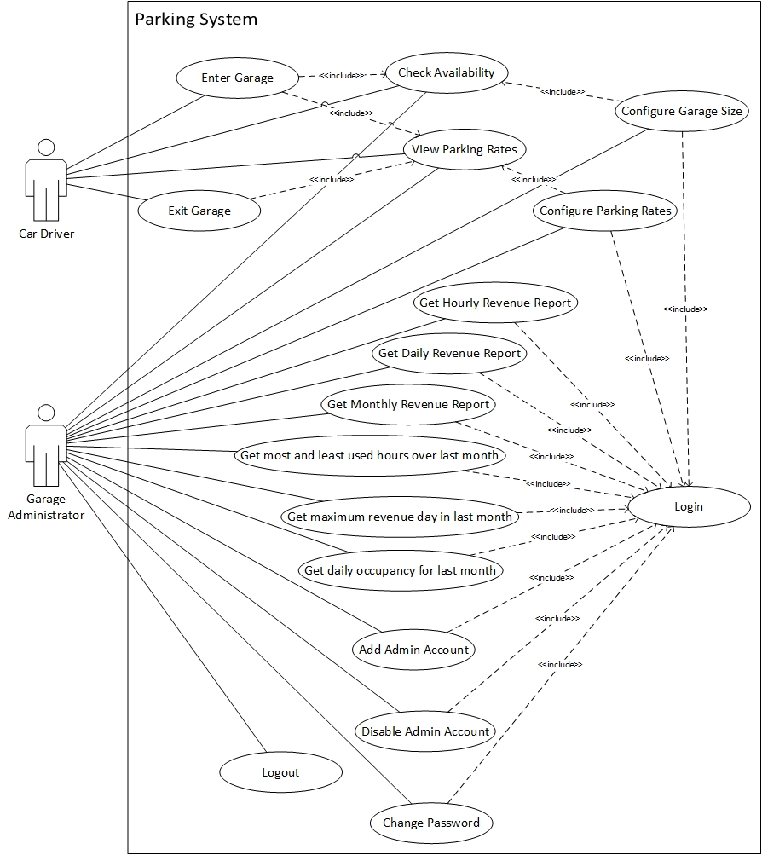

**Use Case UC1: Enter Garage**

**Primary Actor:** Car Driver

**Stakeholders and Interests:**

* Car Driver: Wants to park car in a parking spot in the parking garage.
* Garage Administrator: Wants to record the tickets issued for parking.

**Success Guarantee (Postconditions):** Driver has a valid ticket number and has parked in the garage.

**Main Success Scenario (or Basic Flow):**

1. Car Driver drives up to the garage entry gate and checks the Parking Availability.
2. Car Driver prompts system for a ticket number.
3. System displays the current garage parking rates.
4. System issues a unique ticket number for the Car Driver.
5. System records the current time as the entry time for the issued ticket.
6. System opens the entry gate, lets the car in and closes the gate.
7. System now has one less available parking slot.

**Extensions (or Alternative Flows):**

2a. The parking garage is full:

1. System does not allow driver to get ticket number.

4a. System does not issue ticket number:

1. The Car Driver can call for Technical Support.

6a. Entry Gate does not open:

1. The Car Driver can call for Technical Support.

6b. Entry Gate does not close:

1. The system will issue warning to the Garage employees.

**Frequency of Occurrence:** Could be nearly continuous.

**Use Case UC2: Exit Garage**

**Primary Actor:** Car Driver

**Stakeholders and Interests:**

* Car Driver: Wants to exit the parking lot.
* Garage Administrator: Wants drivers to pay for parking in full.

**Preconditions:**  The car was parked in the garage.

**Success Guarantee (Postconditions):** Driver has paid for the parking correctly and the then occupied parking slot is now available.

**Main Success Scenario (or Basic Flow):**

1. Car Driver drives up to the exit gate and views the parking rates.
2. System prompts Car Driver to enter correct ticket number.
3. Driver submits ticket number.
4. System calculates parking fee for that ticket and displays the amount.
5. Driver submits the parking fee and it is successfully processed.
6. System opens the gate, lets the car leave and closes the gate.
7. System records the time the payment was made.
8. System makes one more parking slot available.

**Extensions (or Alternative Flows):**

2a. System does not prompt for ticket number:

1. The Car Driver can call for Technical Support.

3a. Driver has lost ticket:

1. System prompts Driver to pay the parking fee for the entire day.

3b. Driver enters an already used ticket number:

1. System prompts Driver to try again or call for Technical Support.

3c. Driver enters invalid ticket number:

1. System prompts Driver to try again or call for Technical Support.

5a. Driver wants to pay by cash:

1. Driver enters cash amount.

1a. Driver has entered more cash amount than the parking fee.

1. System returns the change.

1b. Driver has entered less cash than the parking fee.

1. System prompts for the remaining amount.

*Step 5 is repeated until remaining amount is zero.*

5b. Driver wants to pay by credit card:

1. Driver submits 16 digit credit card number, 3 digit security code, expiry month and year using the credit card reader.
2. The credit card authorization service checks if credit card number is 16 digit long, security code is 3 digit long and month and year are valid and in the future.

2a. Credit Card details are not valid:

1. System prompts for the remaining amount.

*Step 5 is repeated until remaining amount is zero.*

2b. Credit card details are valid.

1. System charges the predetermined parking fee to the driver’s credit card.

5c. Driver does not have money to pay:

1. System prompts Driver to enter name, driver’s license number and records the exception.

6a. Exit Gate does not open:

1. The Car Driver can call for Technical Support.

6b. Exit Gate does not close:

1. The system will issue warning to the Garage employees.

**Technology and Data Variations List:**

1. Cash amount is entered using a keyboard.

5. Credit card details are submitted using the credit card reader.

**Frequency of Occurrence:** Could be nearly continuous.

**Open Issues:**

* If Driver does not have money to pay, system will record his name and driver’s license number. Any other process required is out of scope for this project.

**Use Case UC3: Check Availability**

**Primary Actor:** Car Driver, Garage Administrator

**Stakeholders and Interests:**

* Car Driver: Wants to find out if a parking slot is available.
* Garage Administrator: Wants to find out if a parking slot is available.

**Preconditions:**

**Success Guarantee (Postconditions):** Car Driver / Garage Administrator has determined if a parking slot is available or not.

**Main Success Scenario (or Basic Flow):**

1. Car Driver / Garage Administrator drives up to or walks up to the entry gate and prompts for system to display garage availability.
2. System displays the number of available parking slots out of the total parking slots in the garage.

**Frequency of Occurrence:** Could be nearly continuous.

**Use Case UC4: View Parking Rates**

**Primary Actor:** Car Driver, Garage Administrator

**Stakeholders and Interests:**

* Car Driver: Wants to view current parking rates.
* Garage Administrator: Wants to view current parking rates.

**Success Guarantee (Postconditions):** Car Driver / Garage Administrator has viewed the current parking rates.

**Main Success Scenario (or Basic Flow):**

1. Car Driver / Garage Administrator drives up to or walks up to the entry or exit gate and prompts for system to display current parking rates.
2. System displays the current parking rates for the garage.

**Frequency of Occurrence:** Could be nearly continuous.

**Use Case UC5: Login**

**Primary Actor:** Garage Administrator

**Stakeholders and Interests:**

* Garage Administrator: Wants to log in to the parking system.

**Success Guarantee (Postconditions):** Garage Administrator has successfully logged into the system and has access to the parking records.

**Main Success Scenario (or Basic Flow):**

1. Garage Administrator prompts system to display the login screen.
2. System prompts Garage Administrator to enter username and password.
3. Garage Administrator submits username and password.
4. System checks if username and password are valid.
5. Garage Administrator is logged into the parking system.

**Extensions (or Alternative Flows):**

3a. Garage Administrator has forgotten password:

1. System displays the Security question and prompts Admin to enter Security Answer.
2. Garage Administrator submits Security Answer.

2a. Security Answer is correct:

1. System prompts Garage Administrator to enter new password.
2. Garage Administrator submits new password.
3. Password is successfully changed.

*Repeat Step 3.*

2b. Security Answer is incorrect:

1. Garage Administrator should exit and call for Technical Support.

2c. Garage Administrator has forgotten Security Answer:

1. Garage Administrator should exit and call for Technical Support.

4a. Username and password combination is incorrect:

1. System displays incorrect username or password error and prompts Garage Administrator to try again or Cancel.

*Repeat from Step 3.*

**Technology and Data Variations List:**

1. The system does not allow spaces or special characters to be entered for username or password.

**Open Issues:**

* The passwords for the Garage Administrator accounts are stored in plain-text in the system.

**Use Case UC6: Logout**

**Primary Actor:** Garage Administrator

**Stakeholders and Interests:**

* Garage Administrator: Wants to log out of the parking system.

**Success Guarantee (Postconditions):** Garage Administrator has successfully logged out of the system.

**Main Success Scenario (or Basic Flow):**

1. Garage Administrator logs out of the parking system.
2. System displays message that Garage Administrator has successfully logged out.

**Open Issues:**

* Any other authorization process for the Garage Administrator is out of scope for the project.

**Use Case UC7: Configure Garage Size**

**Primary Actor:** Garage Administrator

**Stakeholders and Interests:**

* Garage Administrator: Wants to change number of parking slots for the garage.

**Preconditions:** Garage Administrator is identified and authenticated into the system.

**Success Guarantee (Postconditions):** Garage Administrator has successfully changed the total number of parking slots in the parking garage.

**Main Success Scenario (or Basic Flow):**

1. Garage Administrator views the current parking availability.
2. System prompts Garage Administrator to configure number of parking slots in the garage.
3. Garage Administrator configures the parking garage size.

**Extensions (or Alternative Flows):**

3a. New size is zero:

1. System displays error that parking size cannot be zero and prompts Garage Administrator to try again.

*Repeat Step 3.*

3b. New size is negative:

1. System displays error that parking size cannot be negative and prompts Garage Administrator to try again.

*Repeat Step 3.*

3c. New size is less than number of occupied slots:

1. System displays error that parking size cannot be less than number of occupied parking slots and prompts Garage Administrator to try again.

*Repeat Step 3.*

3d. New size is same as before:

1. System acknowledges no change and does not make any changes.

**Use Case UC8: Configure Parking Rates**

**Primary Actor:** Garage Administrator

**Stakeholders and Interests:**

* Garage Administrator: Wants to change parking rates.

**Preconditions:** Garage Administrator is identified and authenticated into the system.

**Success Guarantee (Postconditions):** Garage Administrator has successfully changed the parking rates.

**Main Success Scenario (or Basic Flow):**

1. Garage Administrator views the current parking rates.
2. System prompts Garage Administrator to configure parking rates.
3. Garage Administrator configures the parking rates for 30 minutes, 1 hour, 2 hours, 10 hours and full day.

**Extensions (or Alternative Flows):**

3a. Garage Administrator enters negative amounts.

1. System displays error that parking rates cannot be negative and prompts Garage Administrator to try again.

*Repeat Step 3.*

**Open Issues:**

* System does not check if the parking rates entered are logically correct, as it is out of scope for the project.

Examples of logically incorrect rates: Parking Rate for 1 hour is more than Parking Rate for 2 hours, Parking Rate is zero.

**Use Case UC9: Get Hourly Revenue Report**

**Primary Actor:** Garage Administrator

**Stakeholders and Interests:**

* Garage Administrator: Wants to find out revenue generated by the parking garage hourly for a particular day.

**Preconditions:** Garage Administrator is identified and authenticated into the system.

**Success Guarantee (Postconditions):** Garage Administrator has successfully viewed correct hourly revenues for the particular day.

**Main Success Scenario (or Basic Flow):**

1. Garage Administrator enters a particular date to find out hourly revenues for that day.
2. System displays revenue in dollars for each hour of that day.

**Extensions (or Alternative Flows):**

1a. Date is in future:

1. System displays error and prompts Garage Administrator to try again.

**Use Case UC10: Get Daily Revenue Report**

**Primary Actor:** Garage Administrator

**Stakeholders and Interests:**

* Garage Administrator: Wants to find out revenue generated by the parking garage daily for a particular month.

**Preconditions:** Garage Administrator is identified and authenticated into the system.

**Success Guarantee (Postconditions):** Garage Administrator has successfully viewed correct daily revenues for the particular month.

**Main Success Scenario (or Basic Flow):**

1. Garage Administrator enters a particular month to find out daily revenues for that month.
2. System displays revenue in dollars for each day of that month.

**Extensions (or Alternative Flows):**

1a. Month is in future:

1. System displays error and prompts Garage Administrator to try again.

**Use Case UC11: Get Monthly Revenue Report**

**Primary Actor:** Garage Administrator

**Stakeholders and Interests:**

* Garage Administrator: Wants to find out revenue generated by the parking garage monthly for a particular year.

**Preconditions:** Garage Administrator is identified and authenticated into the system.

**Success Guarantee (Postconditions):** Garage Administrator has successfully viewed correct monthly revenues for the particular year.

**Main Success Scenario (or Basic Flow):**

1. Garage Administrator enters a particular year to find out monthly revenues for that year.
2. System displays revenue in dollars for each month of that year.

**Extensions (or Alternative Flows):**

1a. Year is in future:

1. System displays error and prompts Garage Administrator to try again.

**Use Case UC12: Get most and least used hours over last month**

**Primary Actor:** Garage Administrator

**Stakeholders and Interests:**

* Garage Administrator: Wants to find out hours with highest and lowest occupancy over last month.

**Preconditions:** Garage Administrator is identified and authenticated into the system.

**Success Guarantee (Postconditions):** Garage Administrator has successfully viewed which hours had highest and lowest occupancy with their occupancy percentages over the last month.

**Main Success Scenario (or Basic Flow):**

1. Garage Administrator enters command into the system to find out the most and least used hours for the parking garage over the last month.
2. System displays the hours that had highest and lowest occupancy with their occupancy percentages over the last month.

**Use Case UC13: Get maximum revenue day in last month**

**Primary Actor:** Garage Administrator

**Stakeholders and Interests:**

* Garage Administrator: Wants to find out which day had the most revenue in the last month.

**Preconditions:** Garage Administrator is identified and authenticated into the system.

**Success Guarantee (Postconditions):** Garage Administrator has successfully viewed which day had the most revenue in the last month.

**Main Success Scenario (or Basic Flow):**

1. Garage Administrator enters command into the system to find out which day had the most revenue in the last month.
2. System displays the day which had the most revenue in the last month with the revenue in dollars.

**Use Case UC14: Get daily occupancy for last month**

**Primary Actor:** Garage Administrator

**Stakeholders and Interests:**

* Garage Administrator: Wants to find out the daily occupancy for the last month.

**Preconditions:** Garage Administrator is identified and authenticated into the system.

**Success Guarantee (Postconditions):** Garage Administrator has successfully viewed daily occupancy for the last month.

**Main Success Scenario (or Basic Flow):**

1. Garage Administrator enters command into the system to find out daily occupancy for the last month.
2. System displays daily occupancy count for each day in the last month.

**Use Case UC15: Add Admin Account**

**Primary Actor:** Garage Administrator

**Stakeholders and Interests:**

* Garage Administrator: Wants to add account for a garage Administrator.

**Preconditions:** Garage Administrator is identified and authenticated into the system.

**Success Guarantee (Postconditions):** Garage Administrator has successfully added a Garage Administrator account into the system.

**Main Success Scenario (or Basic Flow):**

1. Garage Administrator enters command into the system to add another Garage Administrator account.
2. System prompts the user to enter username.
3. User submits a username.
4. System prompts user to enter password.
5. User submits password.
6. System prompts user to enter a Security Question.
7. User submits Security Question.
8. System prompts user to enter the Security Answer.
9. User submits Security Answer.
10. System creates a Garage Administrator account with the supplied username, password, Security question and Answer.

**Extensions (or Alternative Flows):**

3a. Username already exists in the system:

1. System prompts Garage Administrator to enter another username.

**Special Requirements**:

* The system comes with a pre-generated Administrator account with username and password as admin, admin.

**Technology and Data Variations List:**

1. The system does not allow spaces or special characters to be entered for username or password.

**Open Issues:**

* The Garage Administrator facilitates the process of creating an Admin account for a user. The Garage Administrator is logged into the system and the user can enter account username, password, Security question and answer.

**Use Case UC16: Disable Admin Account**

**Primary Actor:** Garage Administrator

**Stakeholders and Interests:**

* Garage Administrator: Wants to disable account for a Garage Administrator.

**Preconditions:** Garage Administrator is identified and authenticated into the system.

**Success Guarantee (Postconditions):** Garage Administrator has successfully disabled the Garage Administrator account in the system.

**Main Success Scenario (or Basic Flow):**

1. Garage Administrator enters command into the system to disable a Garage Administrator account.
2. System prompts Garage Administrator to enter username.
3. Garage Administrator enters a username.
4. System disables the Garage Administrator account with that username and records username of the Garage Administrator who authorized it.

**Extensions (or Alternative Flows):**

3a. Username does not exist in the system:

1. System prompts Garage Administrator to enter another username or cancel.

3b. Garage Administrator enters own username:

1. System prompts Garage Administrator to enter another username or cancel.

**Special Requirements**:

* The system comes with a pre-generated Administrator account with username and password as admin, admin.

**Technology and Data Variations List:**

1. The system does not allow spaces or special characters to be entered for username or password.

**Open Issues:**

* Any Garage Administrator can disable any other Garage Administrator account. Higher privileges are not provided to select accounts as this is out of scope for this project.

**Use Case UC17: Change Password**

**Primary Actor:** Garage Administrator

**Stakeholders and Interests:**

* Garage Administrator: Wants to change password for his account.

**Preconditions:** Garage Administrator is identified and authenticated into the system.

**Success Guarantee (Postconditions):** Garage Administrator has successfully changed his account password into the system.

**Main Success Scenario (or Basic Flow):**

1. System prompts Garage Administrator to enter old password.
2. Garage Administrator enters old password.
3. System prompts Garage Administrator to enter new password.
4. Garage Administrator enters new password.
5. System prompts Garage Administrator to re-enter the new password.
6. Garage Administrator re-enters the new password.
7. System changes the account password for the Garage Administrator.

**Extensions (or Alternative Flows):**

2a. Password is incorrect:

1. System prompts Garage Administrator to re-enter password or Exit.

6a. Password re-entered does not match the new password entered previously:

1. System prompts Garage Administrator to re-enter password or Exit.

**Technology and Data Variations List:**

2, 4, 6. The system does not allow spaces or special characters to be entered for username or password.

**Domain Model**

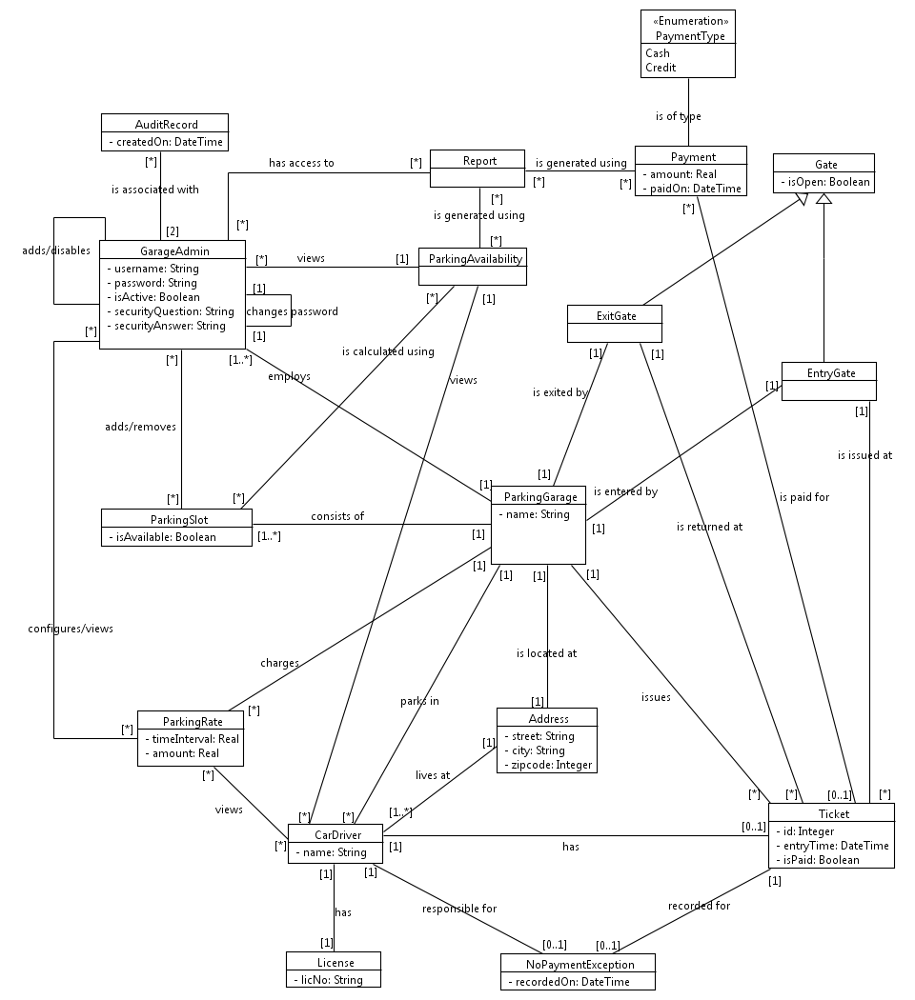

**Glossary**

**Definitions**

|  |  |  |
| --- | --- | --- |
| Term | Definition and Information | Aliases |
| Parking Garage | A building or space located at a specific address with at least one parking slot for parking cars only. | Parking,  Garage,  Parking Lot |
| Address | The address consists of street, city and zipcode.  Street can contain the block number as well as the street name. | Location |
| Zipcode | 5 digit basic zipcode of location. | Pincode |
| Gate | A physical structure that can open or close and provide access to the Parking Garage.  This parking has two gates, one for entering and one for exiting.  isOpen checks if the gate is open or not. |  |
| Entry Gate | EntryGate is a type of Gate. It is used to enter the parking lot. It cannot be used to exit the parking. |  |
| Exit Gate | ExitGate is a type of Gate. It is used to exit the parking lot. It cannot be used to enter the parking. |  |
| Parking Slot | ParkingSlot is a small area in the Parking Garage in which a single car can be parked.  The Parking Garage will have at least one ParkingSlot.  isAvailable denotes whether the ParkingSlot is empty or has a car parked in it. | Parking Spot,  Slot,  Parking space |
| Parking Availability | Parking Availability of the Garage is calculated using the isAvailable statuses of all the Parking Slots.  It gives the occupied / unoccupied Parking Slots along with the total number of slots. | Garage Availability |
| Parking Size | The total number of Parking Slots in the Parking. |  |
| Car Driver | Person who drives the car into and out of the Parking lot. | Driver |
| License | The Driver’s License issued to the Driver for safe driving. Currently, there is no check to determine if license number entered as String is valid or not. | Driving License,  Driver’s License |
| Parking Rate | The amount a Car Driver has to pay for parking the car in the Parking Lot for a specified time interval.  The time interval can be 30 minutes (0.5 hour), 1 hour, 2 hours, 10 hours and 24 hours. |  |
| Ticket | A number (not a physical piece of paper) issued to the Car Driver at the Entry Gate. This number will be unique every time it is given out.  It is said to be ‘returned’ at the Exit Gate by the Driver.  This is a 6-digit number without any leading/trailing zeroes or decimal points.  entryTime is the time when the ticket is issued to the Driver.  isPaid is true if the entire amount for the ticket is paid in full. | Parking Ticket |
| Payment | A payment has to be made by the Driver when the ticket is returned or lost.  The payment is calculated using the Parking Rates, entryTime of the Ticket and the current time.  It does not involve real money or paper notes or physical credit cards. Only numbers will be used to denote Payment. | Parking fee |
| No Payment Exception | When a Driver does not have money to pay or does not want to pay for the ticket, a No Payment Exception is recorded which is associated with the particular Car Driver and the Ticket. | Payment Exception |
| Payment Type | Payment Type is an enumeration of types of Payment. Currently, it supports type ‘Cash’ and ‘Credit’. |  |
| Garage Admin | Person who has authorized access to the computerized Parking System. He can change Parking Rates, Parking Size, view Reports, add / disable other Admin accounts or change own password.  isActive denotes whether an account is active or disabled.  Security Question and Answer are helpful for the Garage Admin who has forgotten password. | Garage Adminstrator,  Parking Admin / Administrator,  Admin |
| Audit Record | An Audit Record is created when an Admin account is disabled by another Administrator. | Audit |
| Report | This denotes the different kinds of statistical information prepared for the Garage Admin to view. |  |